  **Programme: Computer Engineering** **Academic Year: 2024 – 2025 Course: Web Page Designing Course Code: WPD(312004) Semester : Second**

**MICRO PROJECT REPORT**

**ON**

**Travel Vista Agencies**

**_____________________________________**

**Submitted by the group of 5 students,**

|  |  |  |  |  |
| --- | --- | --- | --- | --- |
| **Sr. No** | **Roll No** | **Name** | **Enrollment No** | **Seat No** |
| 1 | 76 | Manasi Vijay Patil | 24610960246 | 405441 |
| 2 | 72 | Kaveri Vijay Patil | 24610960243 | 379246 |
| 3 | 128 | Tanishka Mahesh Wagh | 24610960298 | 379302 |
| 4 | 122 | Vaibhavi Suhas Varade | 24610960292 | 405487 |
| 5 | 93 | Yogeshwari Ravindra Pawar | 24610960263 | 405458 |

Under the Guidance of

**Ms. Shraddha S. Hajari**

**in**

Three Years Diploma Programme in Engineering and Technology of

Maharashtra State Board of Technical Education, Mumbai (Autonomous)

ISO 9001: 2008 (ISO/IEC-27001:2013)

**at**

**Shri Shivaji Vidya Prasarak Sanstha’s**

**Bapusaheb Shivajirao Deore Polytechnic – 0059**

**Vidyanagari, Deopur, Dhule-424005**



**MAHARASHTRA STATE BOARD OF TECHNICAL EDUCATION, MUMBAI**

***Certificate***

This is to certify that Mr. / Ms. ________________________________________________________________

of **Sixth Semester** of **Diploma Programme** in **Computer Engineering** at **Shri**

**Shivaji Vidya Prasarak Sanstha’s Bapusaheb Shivajirao Deore Polytechnic, Dhule (Institute Code: 0059)** has completed the **Micro Project** satisfactorily in Subject **Web Page Designing(312004)** in the academic year **2024-2025** as prescribed in the MSBTE curriculum of K Scheme.

|  |  |
| --- | --- |
| Place: Dhule | Enrollment No: ___________________ |
| Date: / 04 / 2025 | Exam. Seat No: ___________________ |

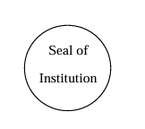**Project Guide** **Head of the Department** **Principal**



**MAHARASHTRA STATE BOARD OF TECHNICAL EDUCATION, MUMBAI**

***Certificate***

This is to certify that,

|  |  |  |  |
| --- | --- | --- | --- |
| **Roll No** | **Enrollment No** | **Name** | **Exam Seat No.** |
| 76 | 24610960246 | Manasi Vijay Patil | 405441 |
| 72 | 24610960242 | Kaveri Vijay Patil | 379246 |
| 128 | 24610960298 | Tanishka Mahesh Wagh | 379302 |
| 122 | 24610960292 | Vaibhavi Suhas Varade | 405487 |
| 93 | 24610960263 | Yogeshwari Ravindra Pawar | 405458 |

students of **Second** Semester **Diploma Programme** in **Computer Engineering** at

**Shri Shivaji Vidya Prasarak Sanstha’s Bapusaheb Shivajirao Deore Polytechnic, Dhule (Institute Code: 0059),** have completed the **Micro Project** satisfactorily in Subject **Web Page Designing (312004)** in the academic year **2024–2025** as prescribed in the MSBTE curriculum of K Scheme.

Place: Dhule Date: / 04/ 2025

**Project Guide** **Head of the Department** **Principal**



**Part A: Micro-Project Proposal**

**Title: APOLLO HOSPITAL**

1. **Aim of the Micro -Project:**

We have created an informative and user-friendly website for Travel Vista using HTML and CSS which provides details about our Travel, company and many more.

1. **Course Outcomes Addressed:**
2. CO1 - Use HTML formatting tags to present content on web page.
3. CO2 - Develop web page using list and hyperlinks.
4. CO3 - Develop web pages using images, colors and backgrounds.
5. CO4 - Design HTML forms using table and frames.
6. CO5 - Apply presentation schemes on content using CSS.
7. CO6 - Publish websites on internet or intranet.
8. **Proposed Methodology:**

We have gathered the required information about Travel Vista,analyze the structure and respective information about the Travel Agencies and created the web-pages using HTML and CSS

**4.0 Action plan:**

|  |  |  |  |  |
| --- | --- | --- | --- | --- |
| **Sr. No.** | **Details of Activity** | **Planned Start date** | **Planned Finish date** | **Name of Responsible Team Members** |
| 1 | Data Collection | 21/01/2025 | 23/01/2025 | Manasi Vijay Patil |
| 2 | Analysis | 25/01/2025 | 30 /01/2025 | Kaveri Vijay Patil |
| 3 | Design | 02 /02/2025 | 10 /02/2025 | Tanishka Mahesh Wagh |
| 4 | Development | 12 /02/2025 | 27/02/2025 | Vaibhavi Suhas Varade |
| 5 | Report Writing | 28 /02/2025 | 05/04/2023 | Yogeshwari Ravindra Pawar |

**5.0 Resource Required:**

|  |  |  |  |  |
| --- | --- | --- | --- | --- |
| **Sr. no** | **Name of resources** | **Specification** | **Quantity** | **Remark** |
| 1 | Computer system | **Processor:** Intel(R) Pentium(R) Dual CPU [E2140@1.60GHz](mailto:E2140@1.60GHz) 1.60GHz  **RAM:** 512 MB | 1 | - |
| 2 | Operating System | **OS:** Windows 7(32bit) | 1 | - |
| 3 | Software | Text editor, Web browser | 1 | - |

**Names of Team Members with Roll Nos.**

|  |  |
| --- | --- |
| **Roll No** | **Name** |
| 76 | Manasi Vijay Patil |
| 72 | Kaveri Vijay Patil |
| 128 | Tanishka Mahesh Wagh |
| **122** | Vaibhavi Suhas Varade |
| 93 | Yogeshwari Ravindra Pawar |

**Part B: Micro-Project Report**

**Title: Travel vista**

**Rationale:**

Overview and scope of problem

**2.0 Aim of the Micro-Project:**

We have created an informative and user-friendly website for Travel Vista using HTML and CSS which provides details about our Travel agencies any more.

**3.0 Course Outcomes Achieved:**

1. CO1 - Use HTML formatting tags to present content on web page.
2. CO2 - Develop web page using list and hyperlinks.
3. CO3 - Develop web pages using images, colors and backgrounds.
4. CO4 - Design HTML forms using table and frames.
5. CO5 - Apply presentation schemes on content using CSS.
6. CO6 - Publish websites on internet or intranet.
7. **Actual Methodology Followed:**
8. Plan and Design
9. Develop the Web Page
10. Test and Publish

**5.0 Actual Resources Used:-**

|  |  |  |  |  |
| --- | --- | --- | --- | --- |
| **Sr. no** | **Name of resources** | **Specification** | **Quantity** | **Remark** |
| 1 | Computer system | **Processor:** Intel(R) Pentium(R) Dual CPU [E2140@1.60GHz](mailto:E2140@1.60GHz) 1.60GHz  **RAM:** 512 MB | 1 | - |
| 2 | Operating System | **OS:** Windows 7(32bit) | 1 | - |
| 3 | Software | Text editor, Web browser | 1 | - |

**6.0 Codes**

< ------------front page-------------------->

<!DOCTYPE html>

<html lang="en">

<head>

<title>Tourism Main Page</title>

<style>

body {

font-family: Arial, sans-serif;

margin: 0;

padding: 0;

}

header {

background-color:#000000;

color: white;

padding: 1rem;

text-align: center;

}

nav {

text-align: center;

background-color: #444;

padding: 1rem;

}

nav a {

color: white;

margin: 0 15px;

text-decoration: none;

}

nav a:hover {

text-decoration: underline;

}

.hero {

background-image: url('GRAPHICS.GIF');

background-size: cover;

color: NAVYBLUE;

text-align: center;

padding: 100px 0;

}

.hero h1 {

font-size: 3rem;

}

.content {

display: flex;

justify-content: space-around;

padding: 2rem;

}

.destination {

background-color: white;

border-radius: 8px;

box-shadow: 0 4px 6px rgba(0, 0, 0, 0.1);

width: 30%;

text-align: center;

padding: 1rem;

}

.destination img {

width: 100%;

height: auto;

border-radius: 8px;

}

footer {

background-color: #333;

color: white;

text-align: center;

padding:1rem;

bottom: 0;

width: 100%;

height:70px;

}

nav ul {

list-style-type: none; /* Remove bullet points */

padding: 0; /* Remove padding */

}

nav ul li {

display: inline; /* Display list items inline */

margin: 0 15px; /* Space between items */

}

nav ul li a {

color: white; /* White text for links */

text-decoration: none; /* Remove underline from links */

font-weight: bold; /* Bold text */

}

nav ul li a:hover {

text-decoration: underline; /* Underline on hover */

}

H4

{

BACKGROUND-COLOR:#0a0a0a;

ALIGN:CENTER;

PADDING:20PX;

color: white;

}

.hero {

background-image:"C:\Users\Lenovo\Documents\html\image.webp";

background-size: cover;

color: white;

text-align: center;

padding: 100px 20px;

}

.card {

border-radius: 10px;

box-shadow: 0 2px 5px rgba(0, 0, 0, 0.2);

overflow: hidden;

transition: transform 0.3s;

width: 350px;

height: 500px;

hspace:30px;

vspace:30px;

}

.card:hover {

transform: translateY(-10px);

}

.card img {

height: 300px;

width:350px;

object-fit: cover;

}

.card-content {

padding: 15px;

}

.card-content h3 {

margin: 0;

font-size: 1.5rem;

color: #333;

}

.card-content p {

color: #666;

margin: 10px 0;

}

.cards{

width: 40%;

display: inline-block;

background-color: white;

border-radius: 5px;

margin: 40px;

box-shadow: 2px 2px 10px black;

}

.cards2{

width: 40%;

height:30%;

display: inline-block;

background-color: white;

border-radius: 5px;

box-shadow: 2px 2px 10px black;

}

.cards3{

width: 40%;

height:40%;

display: inline-block;

background-color: white;

border-radius: 5px;

margin: 40px;

box-shadow: 2px 2px 10px black;

VSPACE:20PX;

}

.cards1{

width: 48%;

height:30%;

display: inline-block;

background-color: white;

border-radius: 5px;

margin: 40px;

box-shadow: 2px 2px 10px black;

}

.cards1 h1 {

color:white;

background-color:black;

}

.cards2 h1{

color:white;

background-color:black;

}

.image img{

width: 100%;

border-top-right-radius: 5px;

border-top-left-radius: 5px;

}

.image1 img{

width: 100%;

height:30%;

border-top-right-radius: 5px;

border-top-left-radius: 5px;

}

.title{

text-align: center;

padding: 5px;

}

.des{

text-align: center;

padding:4px;

}

button{

margin-top: 30px;

margin-bottom: 30px;

background-color: white;

border: 1px solid black;

padding: 10px;

border radius: 5px;

cursor: pointer;

}

button:hover{

color:white;

background-color:black;

transition: .5s;

}

.beaches

{

background-color:#EEEEEE;

}

.beaches h1

{

font-size:36px;

text-align:center;

font-family:Copperplate Gothic,sans-serif;

font-weight:bold;

vspace:20em;

hspace:20em;

}

H5

{

font-family:impact,sans-serif;

font-size:56px;

color:white;

background-color:black;

text-align:center;

}

</style>

</head>

<body >

<header>

<IMG SRC="logo2.webp" HEIGHT="70" WIDTH="70"> <h1>Welcome to Our Tourism Site</h1>

<p>Your gateway to amazing travel destinations</p>

<p> we are the ssvps diploma students and we have designed a website for your great journey and with the best destination plans.</P>

</header>

<header>

<h1>Explore the World</h1>

<nav>

<ul>

<li><a href="index.html">Home</a></li>

<li><a href="about us.html">About Us</a></li>

<li><a href="destinations.html">Destinations</a></li>

<li><a href="contact us final.html">Contact</a></li>

<li><a href="LEARN MORE.html">Learn More</a></li>

<li><a href="FAQs.html">FAQS</a></li>

</ul>

</nav>

</header>

<img src="C:\Users\Lenovo\Documents\html\image.webp" width="1500" height="600">

<h5>More about <b>"TRAVEL VISTA"</b></h5>

< ! -----------------------------cards-----------------------------!>

<div class="beaches">

<div class="cards">

<div class="image">

<img src="https://cdn.dribbble.com/userupload/23637734/file/original-be78cb2e737087a2cecb569fed4ec79b.gif">

</div>

<div class="title">

<h1>Activities:</h1>

</div>

<div class="des">

<p font-size="36px">

<ul>Sightseeing tours and city excursions.</li>

<li>Adventure sports (e.g., hiking, rafting, zip-lining).</li>

<li>Cultural experiences (e.g., local food tasting, traditional shows).</li>

<li>Beach and relaxation trips.</li>

<li>Wildlife safaris and nature walks.</li>

<li>Cruise and boat rides.</li>

<li>Historical and heritage site visits.</li>

<li>Shopping and local market tours.</li>

<li>Camping and eco-tourism experiences</li>

</ul>

</p>

<button> Read more </button>

</div>

</div>

<div class="cards">

<div class="image">

<img src="https://encrypted-tbn0.gstatic.com/images?q=tbn:ANd9GcTtHDczFE1FuJLB0_sat-Mbsn_tUp02KYQREqHASLn-RgmDB8BOTTMLRaOPabjo4KTzWuY&usqp=CAU">

</div>

<div class="title">

<h1>Facilities</h1>

</div>

<div class="des">

<p font-size="36px">

<ul>

<li>Comfortable transportation (buses, vans, private cars).</li>

<li>Hotel and resort bookings.</li>

<li>Tour guides and interpreters.</li>

<li>24/7 customer support.</li>

<li>Travel insurance assistance.</li>

<li>Meal arrangements (customized dietary options).</li>

<li>Pick-up and drop-off services.</li>

<li>Secure luggage handling.</li>

<li>First aid and emergency kits.</li>

<li>Online booking and payment system</li></ul>

<button> Read more </button>

</div>

</div>

<div class="cards">

<div class="image">

<img src="https://media.licdn.com/dms/image/v2/C4D1BAQHRMS2GTUEq6w/company-background_10000/company-background_10000/0/1583758791103/touristsafety_cover?e=2147483647&v=beta&t=JL9IFXBL7CVC-ngR3J1EWT1SkzHT_Pkv_58BRRf3ieA">

</div>

<div class="title">

<h1>Security</h1>

</div>

<div class="des">

<p><ul><i><li> Secure offices, transport, and accommodations with surveillance and access control.<br></li>

<li>Protect customer data via encryption and secure servers.<br></li>

<li>Train staff in safety, first aid, and emergency procedures.<br></li>

<li>Monitor risks in travel destinations and inform clients.<br></li>

<li>Offer travel insurance and crisis support.<br></li>

<li>Use background checks for guides and drivers.<br></li></i>

</ul>

</p>

<button> Read more </button>

</div>

</div>

<div class="cards1">

<div class="image">

<img src="https://blog-content.hiverhq.com/wp-content/uploads/2021/06/customers-love-sharing-their-travel-experiences-online.png">

</div>

<div class="title">

<h1>ratings</h1>

</div>

<!-----Merged Cards-----!>

<div class="cards3">

<h1><button> Customer Ratings </button></h1>

<div class="image">

<img src= "https://www.alchemer.com/wp-content/uploads/2023/03/2022_BenchmarkTables_Travel_RatingsReviews.png">

</div>

</div>

<div class="cards2">

<div class="des">

<h1><button> AWARDS </button></h1>

</div>

<div class="image">

<img src="https://encrypted-tbn0.gstatic.com/images?q=tbn:ANd9GcSMfctH9tiWxgAZBURH5e7Njb5IW6ijntkOvA&s">

</div>

</div>

</div>

<footer>

<p>&copy; 2025 Tourism Website | All Rights Reserved</p>

</footer>

</body>

</html>

< ---------Travel Enrollment -------- >

<!DOCTYPE html>

<html lang="en">

<head>

<meta charset="UTF-8">

<meta name="viewport" content="width=device-width, initial-scale=1.0">

<title>Travel Enrollment</title>

<style>

body {

font-family: Arial, sans-serif;

margin: 0;

padding: 0;

background :linear-gradient(to bottom right, #ffffff, #00f2fe ,#C71585);

color: #fff;

align-items:center;

}

.container {

width: 50%;

margin: 50px auto;

padding: 20px;

background: radial-gradient(circle, #191970,#0000CD);

border-radius: 10px;

box-shadow: 0 4px 6px rgba(0, 0, 0, 0.1);

}

h1 {

text-align: center;

color:#ffffff;

}

label {

display: block;

margin: 10px 0 5px;

}

input, select {

width: calc(100% - 20px);

padding: 10px;

margin: 5px 0 15px;

border: 1px solid #ccc;

border-radius: 5px;

font-size: 16px;

}

button {

width: 100%;

padding: 10px;

font-size: 18px;

color: white;

background: #00a3cc;

border: none;

border-radius: 5px;

cursor: pointer;

}

button {

background: #87CEFA;

}

section {

background-color:#17202a ;

padding: 4em;

margin-bottom: 30px;

box-shaow: 0 0 20px rgba(0, 0, 0, 0.1);}

header nav ul li {

margin-right: 40px;

}

main {

display: flex;

flex-direction: column;

align-items: center;

padding: 3em;

text: #17202a;

}

header nav a {

color: #17202a;

text-decoration: none;}

</style>

</head>

<body>

<div class="container">

<h1>Travel Enrollment</h1>

<form>

<label for="name">Full Name</label>

<input type="text" id="name" name="name" placeholder="Enter your name">

<label for="email">Email</label>

<input type="email" id="email" name="email" placeholder="Enter your email" >

<label for="destination">Preferred Destination</label>

<select id="destination" name="destination" >

<option value="">Select your destination</option>

<option value="paris">Paris</option>

<option value="bali">Bali</option>

<option value="newyork">New York</option>

<option value="tokyo">Tokyo</option>

</select>

<label for="travel-date">Preferred Travel Date</label>

<input type="date" id="travel-date" name="travel-date">

<button type="submit"><a href="main page.html"> Enroll Now</a></button>

</form>

</div>

</body>

</html>

< ----------Contacts------------- >

<!DOCTYPE html>

<html>

<head>

<style>

h1

{font-family:"Engravers MT",sans-serif;

font-size:46px;

text-align: center;

background-color:#B5E7EA;

}

th{

font-size:36px;

}

.input

{

font-size:36px;

}

.input input

{

font-size:90px;

}

</style>

</head>

<body>

<!DOCTYPE html>

<html>

<head>

<title>Contact Us</title>

<style>

.header img

{

width:100%;

}

body {

font-family: Arial, sans-serif;

background-color: #f2f2f2;

}

.contact-container {

width: 80%;

margin: 40px auto;

padding: 20px;

background-color: #fff;

border: 1px solid #ddd;

box-shadow: 0 0 10px rgba(0, 0, 0, 0.1);

border-radius: 10px;

}

h1 {

text-align: center;

color: #333;

margin-bottom: 20px;

}

.card {

background-color: #fff;

padding: 20px;

border: 1px solid #ddd;

box-shadow: 0 0 10px rgba(0, 0, 0, 0.1);

border-radius: 10px;

margin-bottom: 20px;

}

.form-group {

margin-bottom: 20px;

}

label {

display: block;

margin-bottom: 10px;

}

input[type="text"], input[type="email"], input[type="tel"] {

width: 100%;

height: 40px;

margin-bottom: 20px;

padding: 10px;

border: 1px solid #ccc;

border-radius: 20px;

}

textarea {

width: 100%;

height: 100px;

margin-bottom: 20px;

padding: 10px;

border: 1px solid #ccc;

border-radius: 5px;

}

button[type="submit"] {

width: 100%;

height: 40px;

background-color: #4CAF50;

color: #fff;

padding: 10px;

border: none;

border-radius: 5px;

cursor: pointer;

}

button[type="submit"]:hover {

background-color: #3e8e41;

}

.error {

color: #red;

font-size: 12px;

}

.social-media {

margin-top: 20px;

}

.social-media a {

margin-right: 20px;

font-size: 24px;

color: #333;

}

.social-media a:hover {

color: #4CAF50;

}

a

{font-size:20px;

color:#FFFFFF;

}

</style>

</head>

<body>

<div="header">

<img src="C:\Users\Lenovo\Documents\html\about us.jpg" width="1500px" height="400px">

</div>

<div class="contact-container">

<h1>Contact Us</h1>

<div class="card">

<form action="mailto:example@example.com" method="post" enctype="text/plain">

<div class="form-group">

<label for="name">Name:</label>

<input type="text" id="name" name="name" required>

</div>

<div class="form-group">

<label for="email">Email:</label>

<input type="email" id="email" name="email" required>

</div>

<div class="form-group">

<label for="phone">Phone:</label>

<input type="tel" id="phone" name="phone" required>

</div>

<div class="form-group">

<label for="message">Message:</label>

<textarea id="message" name="message" required></textarea>

</div>

<button type="submit"><a href="main page.html">Submit</a></button>

</form>

</div>

<div class="social-media">

<a href="#" target="_blank"><i class="fab fa-facebook-f"></i></a>

<a href="#" target="_blank"><i class="fab fa-twitter"></i></a>

<a href="#" target="_blank"><i class="fab fa-instagram"></i></a>

<a href="#" target="_blank"><i class="fab fa-linkedin-in"></i></a>

</div>

</div>

<p style="font-size:32px">

<b>We are heartfelt for inconvenience by our side.<p></b>

<p style="font-size:32px">If you have any questions or need further assistance, please feel free to reach out to us through the contact form above or via the contact information provided. We look forward to hearing from you!</p>

< -----------About us ---------- >

<!DOCTYPE html>

<html lang="en">

<head>

<title>About Us</title>

<link href="https://cdnjs.cloudflare.com/ajax/libs/font-awesome/6.0.0-beta3/css/all.min.css" rel="stylesheet">

<style>

body {

font-family: 'Segoe UI', Tahoma, Geneva, Verdana, sans-serif;

background: linear-gradient(to right, #e0f7fa, #e1bee7);

margin: 0;

padding: 0;

color: #333;

}

h1 {

font-size: 46px;

text-align: center;

background-color: #b5e7ea;

padding: 25px;

margin: 0;

color: #006064;

text-shadow: 1px 1px 2px #ccc;

}

h2 {

font-size: 38px;

text-align: center;

margin-top: 30px;

color: #4a148c;

}

p {

font-size: 20px;

line-height: 1.6;

padding: 0 20px;

max-width: 1000px;

margin: 10px auto;

text-align: center;

}

.highlight {

font-size: 20px;

line-height: 1.8;

font-weight: bold;

background-color: #ffffffcc;

border-radius: 10px;

padding: 20px;

margin: 20px auto;

width: 90%;

max-width: 1000px;

box-shadow: 0 4px 10px rgba(0, 0, 0, 0.1);

}

pre.highlight {

font-size: 18px;

background-color: #ffffffcc;

border-radius: 10px;

padding: 20px;

width: 90%;

max-width: 1000px;

margin: 20px auto;

box-shadow: 0 4px 10px rgba(0, 0, 0, 0.1);

white-space: pre-wrap;

font-family: inherit;

}

.icons {

font-size: 28px;

text-align: center;

margin-top: 30px;

color: #ff6347;

}

.icons i {

margin: 0 15px;

transition: color 0.3s ease, transform 0.3s ease;

}

.icons i:hover {

color: #2c7dd1;

transform: scale(1.2);

}

.benefits {

display: flex;

justify-content: center;

gap: 40px;

margin: 40px auto;

flex-wrap: wrap;

max-width: 1000px;

}

.benefit {

background-color: #ffffffcc;

border-radius: 12px;

padding: 20px;

width: 200px;

text-align: center;

box-shadow: 0 4px 10px rgba(0, 0, 0, 0.1);

transition: transform 0.3s ease;

}

.benefit:hover {

transform: translateY(-5px);

}

.benefit i {

font-size: 48px;

color: #2c7dd1;

margin-bottom: 10px;

}

.benefit p {

font-size: 18px;

margin: 0;

}

/* Navigation Bar Styles */

.navbar {

background-color: #006064;

padding: 15px 0;

box-shadow: 0 2px 10px rgba(0, 0, 0, 0.1);

position: sticky;

top: 0;

z-index: 1000;

}

.nav-container {

width: 90%;

max-width: 1200px;

margin: 0 auto;

display: flex;

justify-content: space-between;

align-items: center;

}

.nav-logo {

font-size: 22px;

color: #ffffff;

text-decoration: none;

font-weight: bold;

}

.nav-menu {

list-style: none;

display: flex;

gap: 20px;

margin: 0;

padding: 0;

}

.nav-menu li a {

color: #ffffff;

text-decoration: none;

font-size: 16px;

padding: 6px 12px;

border-radius: 4px;

transition: background-color 0.3s;

}

.nav-menu li a:hover {

background-color: #004d40;

}

/* Navigation Bar Styles */

.navbar {

background-color: #006064;

padding: 15px 0;

box-shadow: 0 2px 10px rgba(0, 0, 0, 0.1);

position: sticky;

top: 0;

z-index: 1000;

}

.nav-container {

width: 90%;

max-width: 1200px;

margin: 0 auto;

display: flex;

justify-content: space-between;

align-items: center;

}

.nav-logo {

font-size: 22px;

color: #ffffff;

text-decoration: none;

font-weight: bold;

}

.nav-menu {

list-style: none;

display: flex;

gap: 20px;

margin: 0;

padding: 0;

}

.nav-menu li a {

color: #ffffff;

text-decoration: none;

font-size: 16px;

padding: 6px 12px;

border-radius: 4px;

transition: background-color 0.3s;

}

.nav-menu li a:hover {

background-color: #004d40;

}

</style>

</head>

<body>

<h1>About Us &#8594;</h1>

<nav class="navbar">

<div class="nav-container">

<a href="index.html" class="nav-logo">Travel Explore</a>

<ul class="nav-menu">

<li><a href="index.html">Home</a></li>

<li><a href="about.html">About Us</a></li>

<li><a href="destination.html">Destinations</a></li>

<li><a href="contact.html">Contact Us</a></li>

</ul>

</div>

</nav>

<h2>Why Travel Vista...&#63;</h2>

<p>Because Travel Vista means a lot more, that too, at Your Price &#10032;</p>

<p class="highlight">

Travel Vista's all-inclusive packages have delighted travelers for decades. Our motto is simple: deliver value for your money while offering the best experiences. Travel with us for an unforgettable journey with zero hassles and all costs included.

</p>

<pre class="highlight">

<span>&#10003;</span> Professional & Caring Tour Leader throughout the tour.

<span>&#10003;</span> Tours for Every Age group, from 7 to 70 years of age.

<span>&#10003;</span> Tours for Every duration consisting of 3 to 40 days.

<span>&#10003;</span> Guarantee of 'Carry Zero Money On tour'.

<span>&#10003;</span> Driver and Tip Included in the tour price.

<span>&#10003;</span> Delicious Indian Meals, Breakfast, Lunch, Dinner - all Meals Included.

<span>&#10003;</span> Embark on unforgettable journeys.

<span>&#10003;</span> We don't just plan trips, we curate experiences.

</pre>

<p>Innovation — that's what Travel Vista loves to create.</p>

<div class="icons">

<i class="fas fa-globe"></i>

<i class="fas fa-plane-departure"></i>

<i class="fas fa-hotel"></i>

<i class="fas fa-umbrella-beach"></i>

</div>

<p>Travel Vista provides exclusive special tours for ladies, students, senior citizens, and trips to exotic destinations for newlyweds. We continuously research new products, themes, and a range of travel upgrades to serve the best to our guests. Whether it's a corporate tour, an adventurous journey, or just a small break, we have plenty of tour choices to suit your taste, requirements, and budget. So, hurry up and book a holiday with Travel Vista!</p>

<div class="benefits">

<div class="benefit">

<i class="fas fa-users"></i>

<p>Family Friendly</p>

</div>

<div class="benefit">

<i class="fas fa-child"></i>

<p>Kids Safe</p>

</div>

<div class="benefit">

<i class="fas fa-cogs"></i>

<p>All-Inclusive</p>

</div>

<div class="benefit">

<i class="fas fa-heart"></i>

<p>Personalized Care</p>

</div>

</div>

</body>

</html>

**7.0 outputs of the Micro Project**

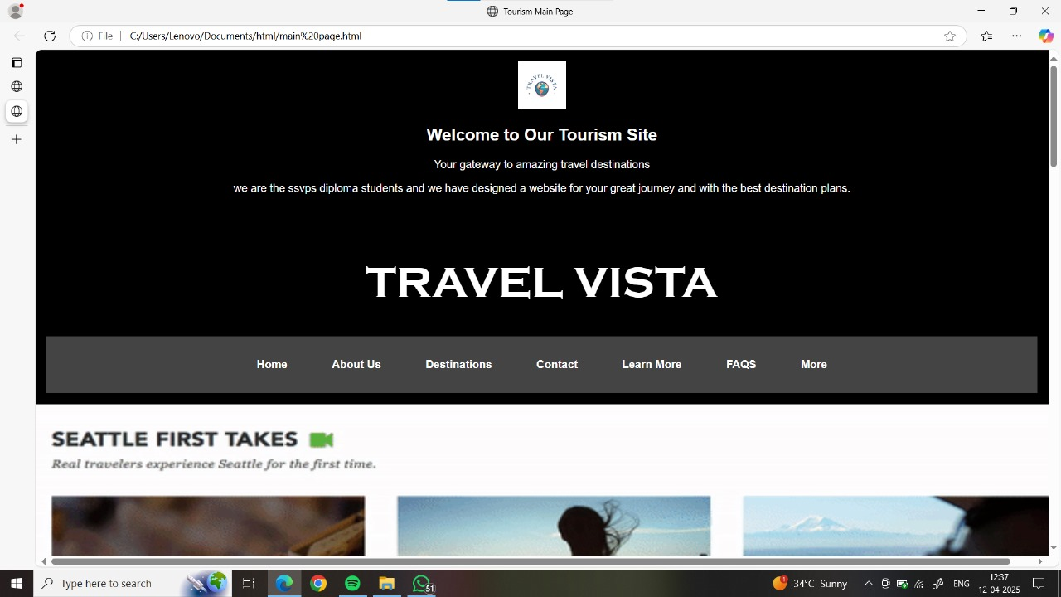 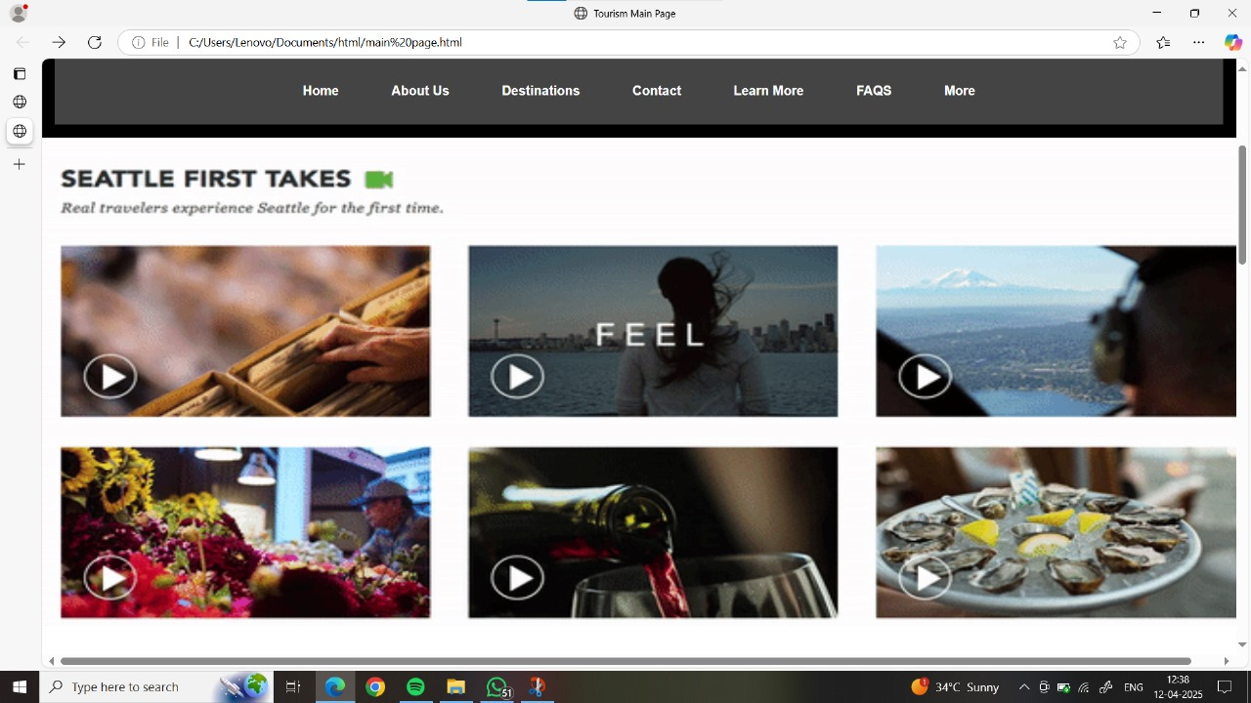

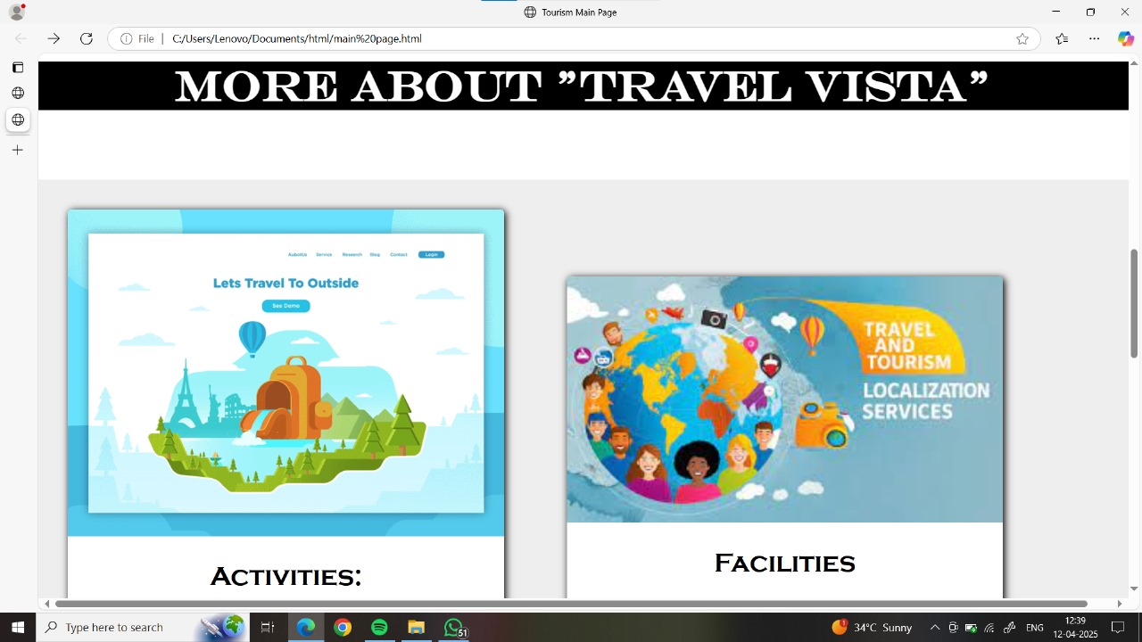 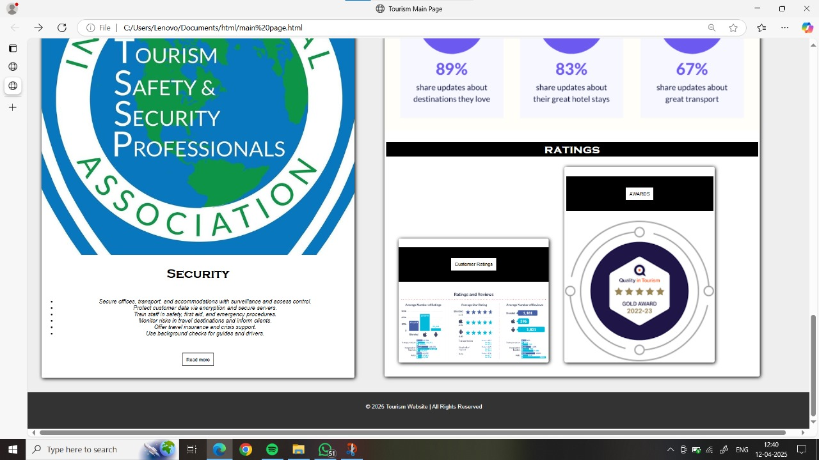

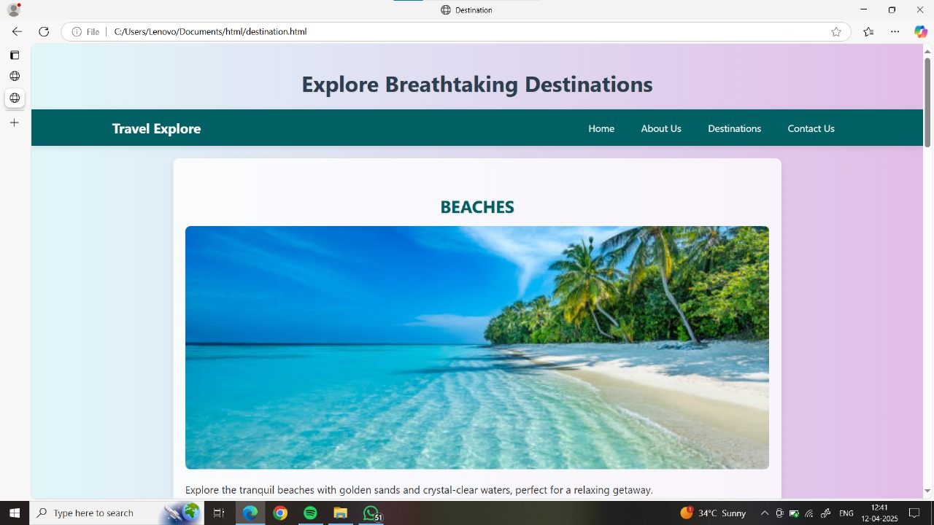 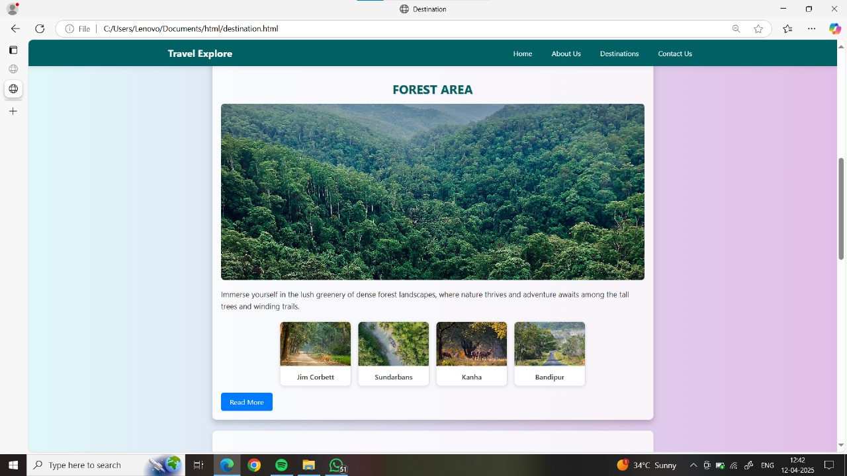

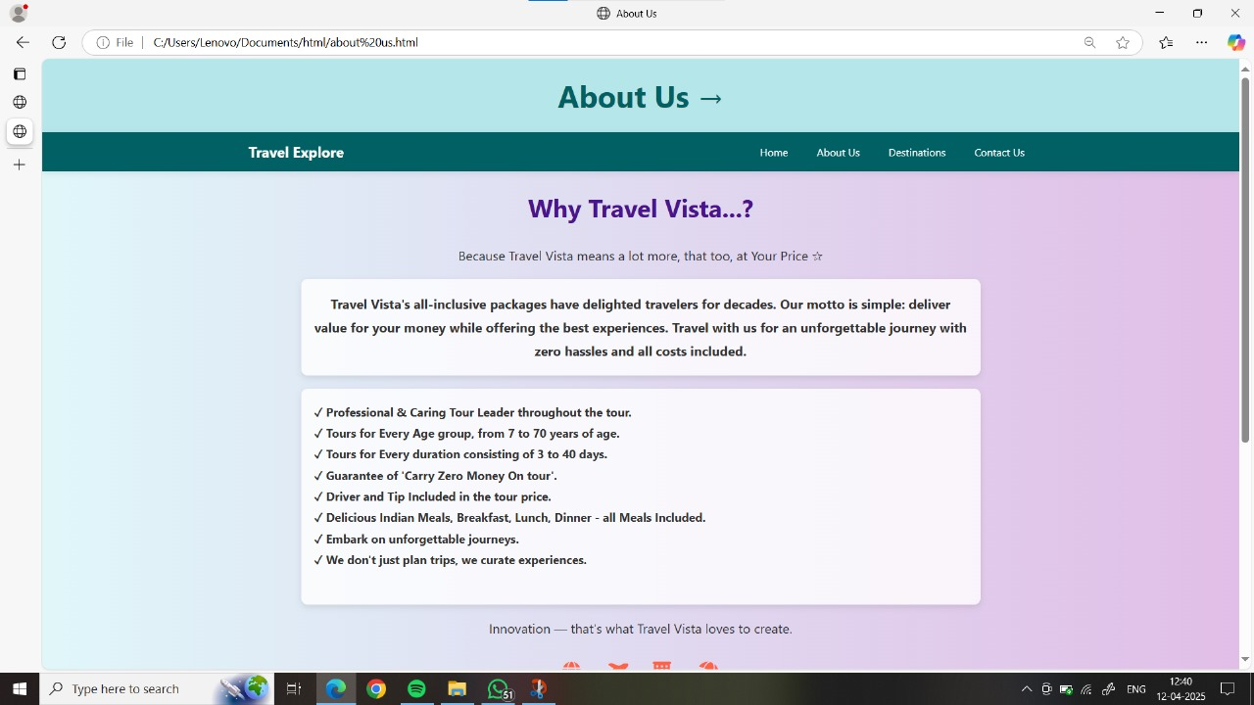 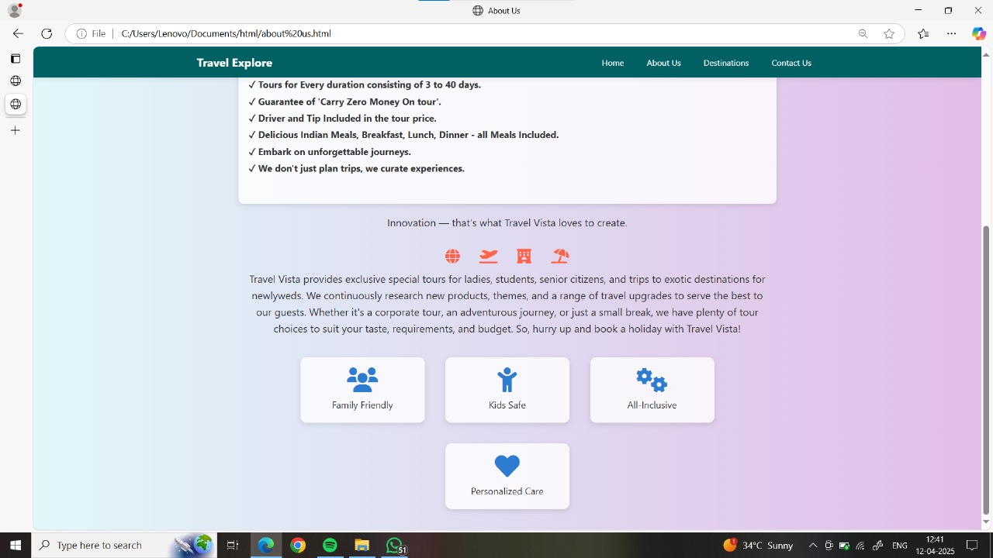

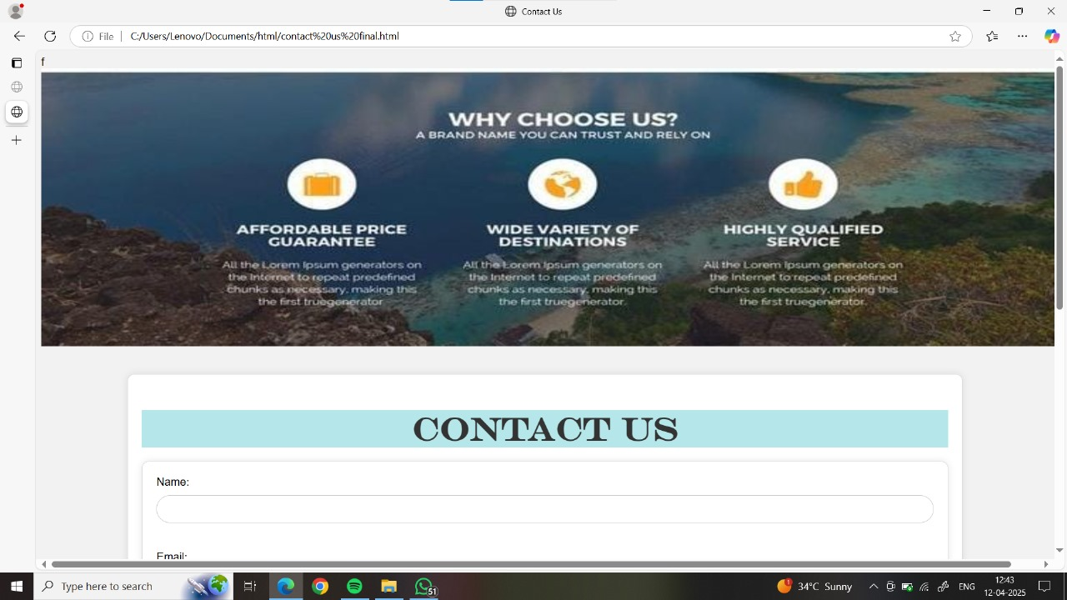 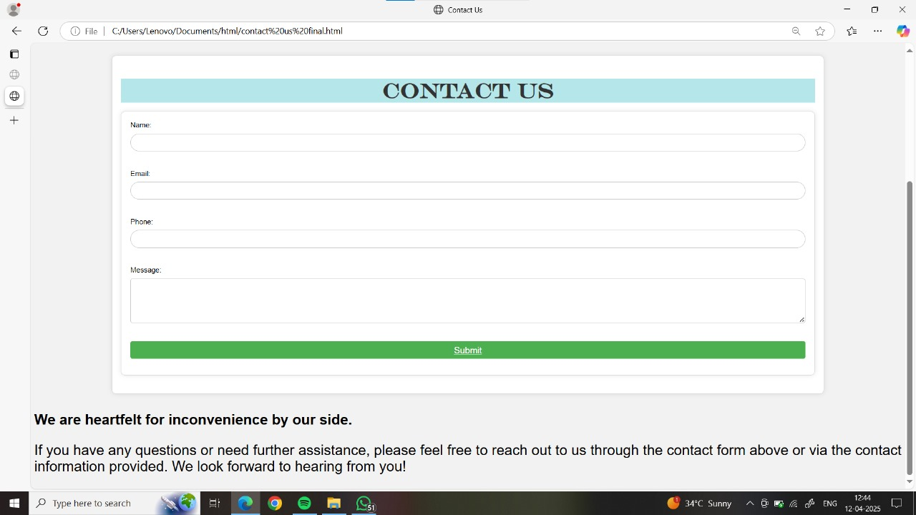

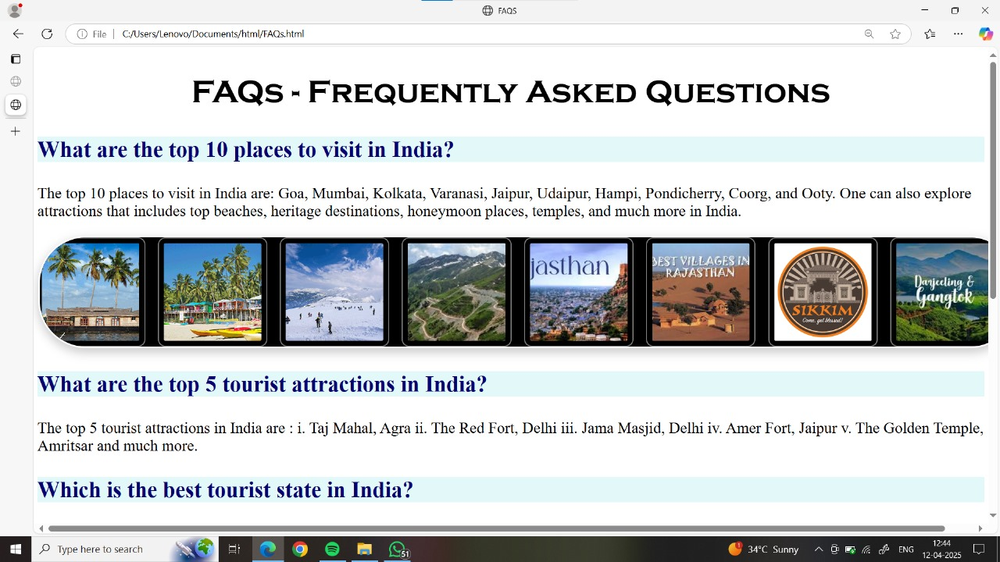 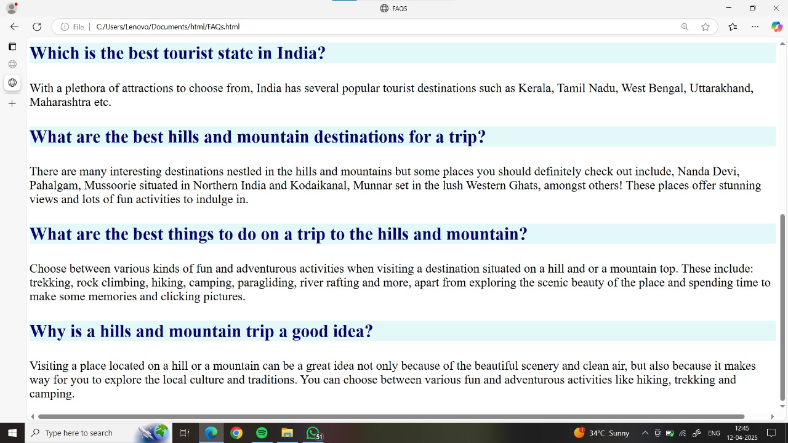

**7.0 Skill Developed/Learning outcome of this Micro-Project:**

* We have learn about HTML and CSS.
* Understand the Webpage designing planning.
* Also learn the value of team collaboration.

**8.0 Application of the Micro-Project:**

It will help travellers for their safe and secure journey. With Travel Vista!